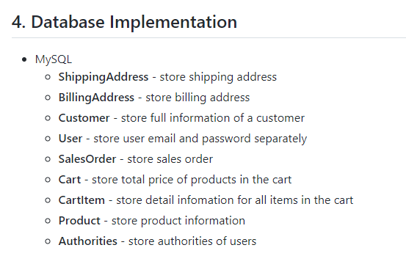

1. Map following in java pojo classes and using hibernate associations

**One to one**

**One to many**

**Many to many**

**Many to one**

As per given diagram

1. Pls perform crud operations on

Customer

2.product

|  |
| --- |
|  |
|  |  |
|  |  |

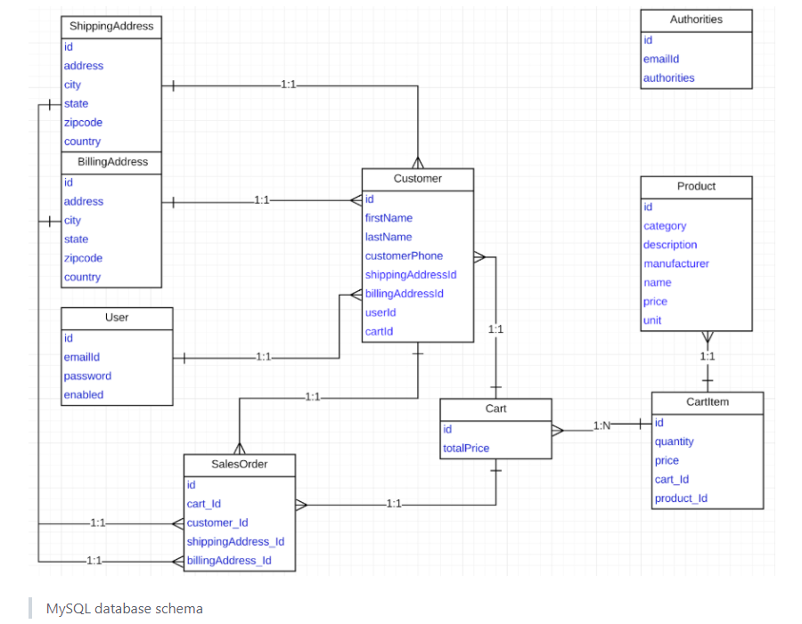

1 . Create an ArrayList al and add 25 random numbers. Write a code to print all the prime numbers that are present in it, using lambda expression.

2.Use Optional class and avoid NullPointerException from the below code:

String names[] = new String[5];

System.out.print(names[0].length( ));

3.Create an Employee class with

1. Instance variables: empNo, name, age, location.

2. A parameterized constructor to initialize them.

Write a program using streams

1. To add five Employee objects into an ArrayList,

2. Filter the Employee objects whose location is Pune,

3. Store them in a separate ArrayList and print their details.